EMPLOYEE ONBOARDING PORTAL
@CREATIVITY THINK (9483175986/7019689991)

ABSTRACT:
Employee Onboarding Portal is a web application designed to streamline the onboarding process for new hires in organizations. Employees can upload required documents, complete training modules, provide feedback, and monitor their progress through an interactive dashboard. Administrators and HR teams manage onboarding tasks, review employee feedback, and analyze progress using analytics dashboards. Built with Django and Django Rest Framework on the backend and React, Recharts, and Dropzone on the frontend, the system provides a secure, structured, and measurable approach to employee onboarding, improving efficiency and engagement..

INTRODUCTION OF THE PROJECT:
Employee onboarding is critical for organizational productivity and employee engagement. This portal simplifies the onboarding process by providing a centralized platform for document uploads, training module completion, feedback collection, and progress tracking. Administrators and HR teams can efficiently monitor employee onboarding progress, assign tasks, and gain insights through analytics dashboards. The application leverages Django, DRF, React, Recharts, and Dropzone to ensure secure data handling, responsive front-end interfaces, and insightful analytics. It aims to enhance employee experience while streamlining administrative oversight..

PROJECT OBJECTIVES:

• Provide employees with a central portal for onboarding tasks
• Enable secure upload and management of required documents
• Facilitate training module completion with progress tracking
• Collect employee feedback on training and processes
• Allow administrators to assign, monitor, and manage onboarding tasks
• Generate analytical insights for HR and management
• Improve overall efficiency and engagement during onboarding

PROBLEM OF THE STATEMENT:
Traditional onboarding involves manual documentation, dispersed training materials, and inefficient progress tracking. Employees may struggle to complete tasks in time, and HR administrators find it difficult to monitor compliance and progress. This project addresses these challenges by centralizing document management, training, feedback, and analytics, providing both employees and HR teams a structured and measurable onboarding system..

MOTIVATION OF THE PROJECT:
• Streamline and simplify employee onboarding processes
• Reduce manual paperwork and task tracking
• Provide interactive dashboards for progress monitoring
• Collect structured feedback for continuous improvement
• Offer HR actionable analytics for better decision-making

BLOCK DAIGRAM OF PROJECT:

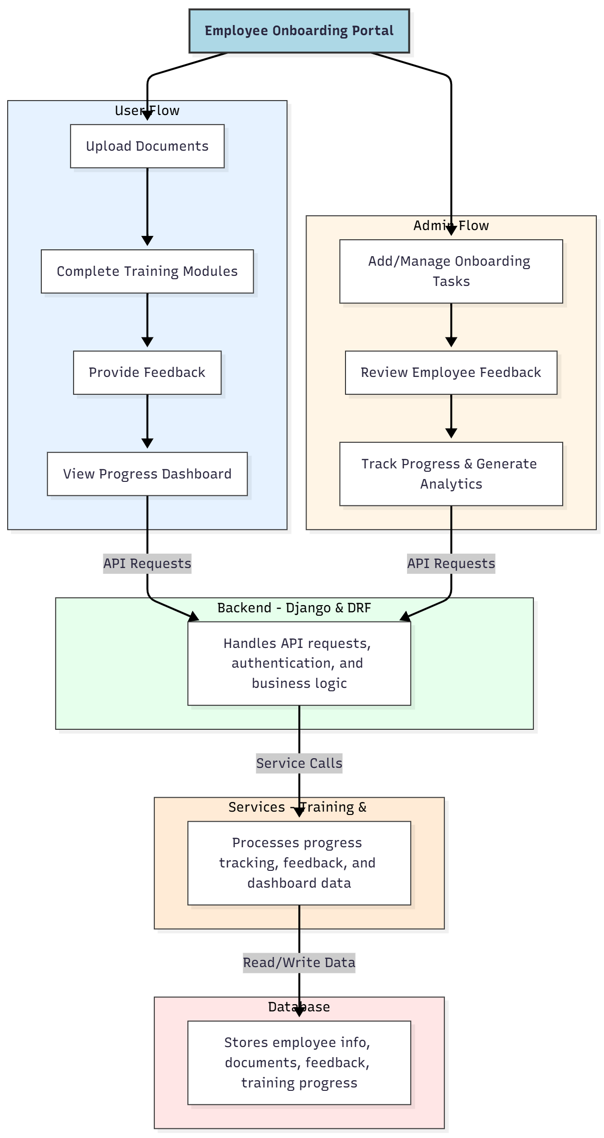

WORKING OF THE PROJECT:
Employees log in to the portal and upload required onboarding documents. They complete assigned training modules sequentially and provide feedback for each module. The dashboard displays progress and completion metrics in real time. The backend handles API requests, authentication, and business logic, while services process analytics and dashboard updates. Administrators add and manage onboarding tasks, review employee feedback, and monitor overall progress using analytics dashboards, ensuring a structured, efficient, and transparent onboarding process..

SOFTWARE REQUIREMENT:
- Backend:
  - Python 3.x
  - Django
  - Django REST Framework
  - SQLite/PostgreSQL
- Frontend:
  - Node.js and npm
  - React.js
  - Axios
- Development Tools:
  - Visual Studio Code
  - Postman (for testing APIs)
  - Git/GitHub (for version control)
- Server/Deployment (Optional):
  - Gunicorn, Nginx, or Heroku/AWS for hosting

ADVANTAGES OF THE PROJECT:

• Centralized onboarding management for employees and HR
• Secure document upload and storage
• Structured training modules with progress tracking
• Feedback collection integrated into workflow
• Real-time progress dashboards
• Efficient task assignment and monitoring for admins
• Analytics for HR decision-making
• Scalable and adaptable to different organizations

APPLICATIONS OF THE PROJECT:
• Corporate HR onboarding
• Employee induction and training programs
• Remote workforce onboarding
• Internship and trainee management
• Small and medium-sized enterprise onboarding
• Government department induction portals
• Employee compliance training tracking
• Analytics-driven onboarding performance evaluation

REFERENCES:

- Django REST Framework Documentation — Django Software Foundation. Django Documentation. Available: https://docs.djangoproject.com/
- Django REST Framework. DRF Documentation. Available: https://www.django-rest-framework.org/
- React. React Official Documentation. Available: https://reactjs.org/docs/getting-started.html
- Redux. Redux Documentation. Available: https://redux.js.org/introduction/getting-started
- PostgreSQL Global Development Group. PostgreSQL Documentation. Available: https://www.postgresql.org/docs/
- MySQL. MySQL Reference Manual. Available: https://dev.mysql.com/doc/
- Git. Git Documentation. Available: https://git-scm.com/doc
- Node.js. Node.js Documentation. Available: https://nodejs.org/en/docs/
- Axios. Axios Documentation. Available: https://axios-http.com/docs/intro
- Socket.io Documentation – https://socket.io/docs/

